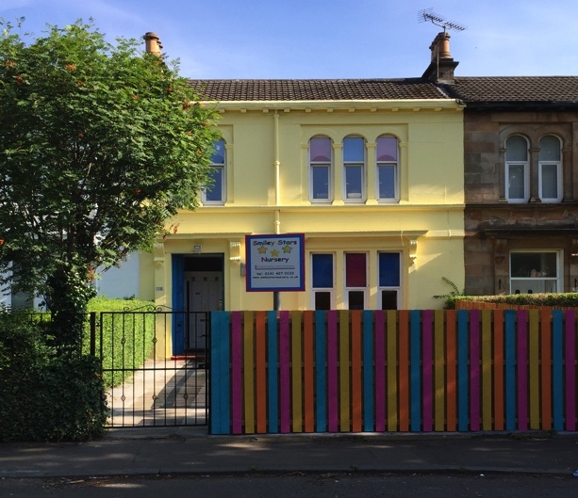

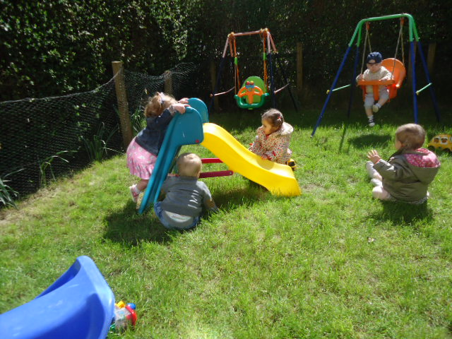
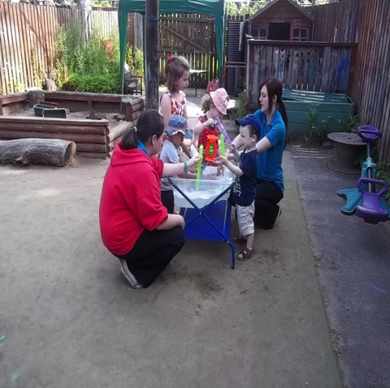

This booklet contains lots of information to help you make a big decision! We know the stresses and strains involved in choosing childcare and we’re here to help.

Smiley Stars is a small, family-run company, we are delighted to introduce you to our nursery. We think it’s something special and we’d like to share it with you.

This booklet contains:

- All-About-Us
- Our location
- Places available
- Our team
- Our opening hours
- Our fees
- Your first visit
- Our day
- Sample menu

We look forward to meeting you. Please call or email to arrange a visit or for more information – we’re always delighted to help.

All-About-Us
At Smiley Stars Nursery, we know that every child is special and that’s why our childcare service is special too. We are a family company and are delighted to introduce you to our service which is for families who want the highest standard of care for their children aged from 6 weeks to 5 years.

The first thing you’ll find with Smiley Stars is a friendly welcome. We want to get to know you because we know that a good relationship with families is the key to your child’s happiness. This helps to build trust - one of the most important things we can give you. Trust that:

- we will give your child the love and care they need and that you expect
- when your child is with us they will be truly safe and secure
- your child will have fun, eat well, enjoy fresh air and exercise balanced with sleep and rest
- Your child will be developing and learning, gaining knowledge, new skills, confidence, independence and self-esteem.

At Smiley Stars, we’re really interested in children – what they need, what they like, what motivates them and how we can provide it. It takes skill to do this, especially with babies and very young children, which is why our staff team has been very carefully chosen.

We’re really interested in families too – we know the stresses of being a working parent and we’d like to help. We have an active Parent Group and can signpost you to various agencies that can help you with issues such as financing your childcare.
Smiley Stars is an active member of Glasgow South West Childcare Partnership Forum and works very closely with Glasgow City Council Education Services and we are in partnership for funded places for 3-5 year olds.

Our Location

We’re at 38 Ibrox Terrace, just around the corner from Ibrox Underground Station. There is lots of free on-street parking and many of our parent’s park here and then get the underground to work. We are very near Paisley Road West, the Clyde Tunnel, The New Queen Elizabeth University Hospital, the M8 and the M77. The Clyde Arc (Squinty!) bridge is a few minutes away, making us even more accessible to the city centre.

Places available
We are registered by the Care inspectorate to care for a maximum of 39 children aged from birth to 5 years.
Please ‘phone, email or see our website for details of any vacancies or to put your name on our waiting list.

Our Team
Staff are the most valuable resource that the children can have and we observe staff: child ratios required by the Care inspectorate to ensure that your child is happy and secure.
Our Manager is Tamara Marashi and Depute Manager is Jane Scott, both well qualified and very experienced practitioners.

As a small nursery, everybody knows everybody else as we work as a whole team. All of our staff are thoroughly vetted, hold the required qualifications and are registered, or in the process of registering, with the Scottish Social Services Council

Staff training is high on our agenda and we offer training in many areas including child protection, infection control, first aid and food hygiene.

Your first visit is very important and you will be made very welcome. You will be shown round our nursery and gardens and introduced to our team. You and your child are welcome to join in with any of the activities and we can chat about the kind of service you require over a cup of coffee. Families come in all shapes and sizes and you’re all welcome at Smiley Stars!

Enrolment
If you decide you would like to join us at Smiley Stars, we will ask you for deposit of £50 which will secure your child’s place. This will be refunded on your child’s last day subject to receiving one month’s notice and payment of all outstanding fees, however should you decide to cancel your place the deposit is non-refundable. And to complete our Registration Form
Settling-in is such an important time and should never be rushed. We encourage you to take as long as you and your child need and will work very closely with you to make sure we’re doing everything we can to help you and your child feel happy and secure with us. Every family’s situation is different so settling-in is agreed on an individual basis to suit not only your child’s needs but your needs too.

Our policies are included in our Parent Information Book which is kept beside our Information Board and is available to all parents.

Opening Hours
We are open from 8.00am to 6.00pm Monday to Friday, 51 weeks of the year. Last pick up time is 5:50 please allow 10 minutes for feedback so staff can leave promptly at 6 pm.

By Arrangement we now offer earlier dropping times at 7am and later picking up time 6.20pm

Our Day
This will vary depending on the stage your child is at. Every child has a Key Worker who is their main carer in the nursery and is responsible for meeting their needs. For registration purposes, the children are based in separate areas of the nursery according to their age. At Smiley Stars however, we firmly believe that the different age groups should have opportunities to come together, e.g. in the garden, at mealtimes and at night when sessions are quieter. This not only benefits their development but also eases transition from one area of the nursery to another.

Mealtimes should be one of life’s pleasures and at Smiley Stars we aim for everyone to enjoy not only the food but also the experience. The children will be given opportunities to set the table, decorate it for special occasions and help to prepare the food. We provide a range of homemade delicious, nutritious meals and snacks, which as far as possible is free from artificial additives and low in sugar and salt. A sample menu is attached. Mealtimes are a great opportunity for socialising and staff will encourage this enjoyable activity by sitting at the table with the children.

Breakfast, lunch and snacks are all included in your fees depending on your session times. Breakfast will be offered to children attending the nursery before 9.00am.

For babies who are weaning we will work with you to ensure your child has the most appropriate diet.
We are a Breastfeeding Welcome accredited nursery and fully support mothers who wish to continue to breastfeed their babies.

If your child has any special dietary requirements and/or have allergies we will work closely with you to ensure your child’s needs are met. (Ingredients are available at the Information Board)

Our Nursery
All children need to be nurtured and cared for well in a safe environment, we observe GIRFEC (Get It Right For Every Child) at all times and we make sure that we follow the curriculums and the guidelines and legislations set by the Scottish government.
Throughout the day
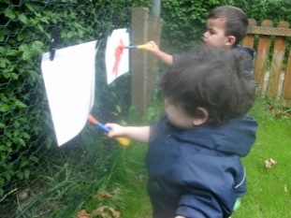
At Smiley Stars, we all share a love of the outdoors and we also enjoy a cosy indoors, to come home to. We have a lovely big terraced house and gardens and lots of good things to play with and enjoy.

Our front door is level with the garden, which is secure for the children to play in. Downstairs is for our babies up to 2 years old.

Our outdoors is as much a playroom and learning experience as the indoors. We use our gardens as much as possible, believing that there’s no such thing as unsuitable weather – only unsuitable clothing.

We have two lovely playrooms and a clean and comfortable changing area. The kitchen and messy playroom are also downstairs. Access to the large, secure back garden is via the back door.

Upstairs we have 2 exciting playrooms for our 2-3 and 5 year olds together with toilets, office and staff room.

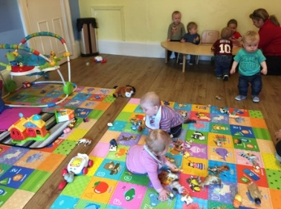
Your child’s Key Worker will ensure that a variety of activities and experiences is offered to complement their care routine – sand, water, drawing, playdough, jigsaws, jumping, climbing, sliding, pushing and pulling to name but a few.

We have so much fun with opportunities for:

- drawing, early writing, books and stories
- science, early number, baking and discovery
- building and small world play
- painting and crafts
- ‘let’s pretend’
- music and movement

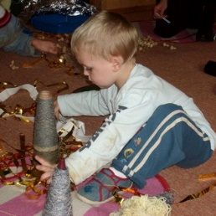
and as often as possible we’re outside
- getting messy and having fun
- running, jumping, skipping and hopping
- climbing, riding, bouncing and sliding
- digging, planting, collecting and sorting
- drawing, painting, taking photos
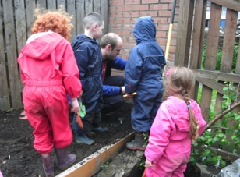
and we don’t forget that sometimes we just need a little rest and to relax……..so when we get towards the end of our day we like to slow things down a bit and get ready for ‘going-home time’ which we will manage to suit your needs. Some parents like to come in for a chat, others want to get home ASAP – whatever you need, we’ll do our best to help.
We follow the children progress through Learning Journals This means that you will now be able to access your child’s profile any time you want, and it will be easier for you to contribute too, as long as you have an internet connection. If you don’t have an internet connection at home you are welcome to view your child’s profile from within the nursery as before by using our computer(s).
There will be mistakes and we may not perfect it for a while so please we need your patience & thoughts to how we can do better.

Security
The system is very secure. You will be the only one outside of the nursery that can view your child’s profile and you will access it with a unique username as well as a password and PIN that you create.

Our Fees
All fees are payable in advance and due in the 1st week of the month. Payment by standing order is preferable. We accept all Childcare Vouchers.

Full fees must be paid during holidays and absences.
Weekly – Breakfast, snacks and lunch included
Monday – Friday 8.00am – 5:50 pm
Daily – Breakfast, snacks and lunch included 8.00am – 5:50 pm
Morning - Breakfast and lunch included 8.00am – 1.00pm
Afternoon - Snack included 1.00pm – 5:50 pm
Dinner |  |  |  | £1
Any Additional hour - Between 8.00am and 6.00pm |  |  |  | £6
SESSION | Baby Room | 2-3 Room | 3-5 Room
Weekly | £180 | £180 | £165
Daily | £41 | £41 | £40
Morning | £25 | £25 | £24
Afternoon | £24 | £24 | £23
Additional hours - (7.00am-8.00am) & (6.00pm-6.20pm)
 | 0-30 mins | 30-45 mins | 45-60 mins
Before 8am | £3 | £4.50 | £6
After 6pm | £3 | - | -
NB. Reduced fees i.e. after a birthday will be applicable the month following each child’s birthday.

A 10% discount based on the oldest child’s fees is given to families with 2 or more children. When a place has been confirmed a £50 deposit is required to secure your child’s place. This will be refunded on your child’s last day subject to receiving one month’s notice and payment of all outstanding fees, however should you decide to cancel your place the deposit is non-refundable.
Please note that Smiley Stars reserves the right to withdraw any offers given at the time of registration and to increase our prices in line with inflation.

As we said before, families come in all shapes and sizes and at Smiley Stars everyone is welcome. We understand that parents can have different working patterns and therefore need childcare that can be adapted to suit their needs.

Please contact the nursery for more information.

Please let us know right away if you anticipate any difficulty with payment. We may be able to help.

Phone us now or email us for a chat - we’d love to hear from you and discuss how we can help with your childcare needs.

Smiley Stars Nursery - Sample Menu
All cooked meals are vegetarian and homemade
Yummy, yummy, yummy, delicious and nutritious, our wholesome and nourishing menus are specially designed to give your little one the very best start in life.
We believe that meal-times should be a happy, relaxed time where children learn social skills, manners, good hygiene practice and healthy eating habits to last them a lifetime.
 | Monday | Tuesday | Wednesday | Thursday | Friday
Breakfast | Selection of Fruit, Selection of cereals. Toast
Lunch | Tomato Mushroom Pasta  Garlic Bread | Veg. Mince & potatoes  Fromage Frais | Fish fingers, croquette & Beans  Fruit Salad | Lasagne  Fromage Frais | Sausage Hotpot  Frozen Mousse
P.M. Snack | Selection of Fruit
 | crackers | Brioche | Fruit loaf | Waffles | Malt Loaf

All meals are served with milk or water
At least 2 types of fruit are served with breakfast and snack

Terms and conditions of enrolment and parental consents

Please read carefully the following terms, conditions and parental consent requirements

Terminology: You, Parents means all parents/guardians or authorised persons, i.e. carers

General Welfare
- Child protection: Smiley Stars management and staff have a duty to take reasonable care to ensure the welfare and safety of the children in our care. Any serious concerns regarding a child’s welfare or safety will be dealt with in accordance with Smiley Stars Child Protection Policy and Procedures. Parents/guardians should be aware that this may require us to contact Social Services.

- Child safety: Children will only be released to parents/guardians or authorised persons, i.e. carers or family members who are known to the nursery staff and permission in writing has been received from the parents/guardians. In unforeseen circumstances where an unauthorised person has to collect the child, the parents/guardians must inform the nursery and provide a password, and we require a proof of photographic ID.

- Confidentiality: All information relating to you and your child is strictly confidential, securely stored and used solely for Smiley Stars Nursery purposes. The only exception to this is in the event of serious concerns regarding a child’s welfare. You are welcome to access your child’s records at any time.

- Child observations and learning Journals: We regularly observe all of the children in our care to ensure that we meet their needs effectively. Observations are recorded in writing, are strictly confidential and are filed in the child’s confidential e-folder. The system is very secure. You will be the only one outside of the nursery that can view your child’s profile and you will access it with a unique username as well as a password and PIN that you create.
- Please do not disclose your access code to anyone
- Please do not upload any of your child’s photos from the system onto the Social Media as some parents have requested not to have their child’s photos on
- It is your responsibility to check the Learning Journals for the accident/incident reports, and all the communication that we update through the system.

- Outings: We will sometimes take the children on outings within the immediate area on foot/using prams and buggies as appropriate. Risk assessments are always carried out in advance and ratios will always be adhered to. You give permission for your child to go on outings within the immediate area. You will ensure that your child is provided with suitable clothing for your child to take part in outdoor activities.

- Tooth-brushing Consent Form: You wish your child to take part in Smiley Stars Tooth-Brushing Policy. The nursery will provide your child with a clearly labeled toothbrush and toothpaste.

- Access to the Internet for the children: Access to the Internet will be under strict supervision from room staff, you give your consent for your child to use the Internet within the Nursery.

- Start and finish times: Children can be cared for within the nursery hours stated on our Registration Certificate on display in the hall. Late collection will invoke an additional charge of £5.00 for every 10 minutes (full or part of) thereafter.

Medical, Health & Wellbeing

- Accidents or emergencies: Every endeavour will be made to contact you in the event of an accident or emergency or the sudden onset of illness but we will not delay in seeking medical help. You will be fully informed of any decisions made. You give permission for Smiley Stars Nursery to take appropriate action in the event of the onset of illness, accident or emergency anaesthetics.

- Medical conditions, allergies and illness: Parents must keep us informed of any allergies, medical conditions and illness affecting their child. Parents must NOT bring their child to nursery if they are ill or have an infectious disease. This is for the health and welfare of ALL children and staff in the nursery. You will be contacted to take your child home if staff considers that your child is not well enough to attend nursery.

- You agree to inform the nursery immediately if your child has, or develops, an allergy, illness or medical condition and to provide the nursery with the information required regarding the allergy or condition to ensure your child’s wellbeing. Smiley Stars staff should not be put in the difficult position of turning a child away at the door because they are obviously not well. Please follow the guidance below to help to promote the health and welfare of everyone involved. Children will not be admitted with infectious diseases (e.g. chicken pox) in accordance with the exclusion periods stated at NHS Exclusion Criteria for Childcare and Childminding Settings

- If a child appears to be clearly unwell, e.g. restless, sick or have a high temperature (above 37.5°C), you will be contacted and asked to take the child home, unless you have signed a Medication Form on the day.

- Medication -prescribed and non-prescribed-: Nursery staff can administer medication required by your child providing that the medication is named for your child and that you have completed a medication consent form, which gives detailed instructions on dosage. Details of medication administered by nursery staff will be recorded and must be signed by you on a daily basis. You must always give the first dose of any medication, and allow time before your child attends the nursery.

- Application of sunscreen &/or nappy cream: You agree that Smiley Stars staff may apply sunscreen/nappy cream to your child’s skin if and when required. You are not aware of any allergy to sunscreen/nappy cream products.

Photographs & Media
You give your permission to take photos & media of your child to be displayed within the nursery and in your child's Learning Journals records and you give permission for the photos to be used for:
- Publicity (e.g. Newspaper articles, Nursery’s website, Facebook & Welcome pack)
- Staff training
- Student portfolios

Communication
- You will provide Smiley Stars with details of ANY issues, which may affect the care, which they provide for your child, as soon as possible

- You will inform Smiley Stars of ANY issues which may result in a change in your child’s behavior and/or if You have experienced a change or difference in your child’s behavior

- You will inform Smiley Stars of ANY changes to your contact details or any other information given on your child’s enrolment form, as soon as possible and will adhere to the Smiley Stars Terms & Conditions

- You will notify the nursery, either by phone call or by Email that your child will not be attending their session.

- It is your responsibility to check your emails and notice sheets for all the events that we announce and all the communication that we update throughout.

Financial
- Fees are payable one month in advance and due on the 1st of each month and no further than 10th of each month. Payment may be made cash or by standing order, we accept childcare vouchers. Late payments will incur an additional charge of £25 per week until full payment is made.

- Extra sessions must be paid for in advance.

- Please note that Smiley Stars reserves the right to withdraw any offers given at the time of registration

- When we confirm your child’s place, a £50 deposit is required which will be refunded when and if you give us 1 month notice prior to you and your child no longer wish to use our services and all fees being up to date from your final invoice. Should you decide to cancel your place, the deposit is non-refundable.

- In order to retain your child’s place, full fees are paid during holidays and absences to retain your child’s place.

- All fees will be increased on an annual base on the first of April of each year

Notice
- You will provide one month’s notice in writing or payment of one month’s fees in lieu of notice must be given if you wish to withdraw your child from the nursery, and receive your deposit back.

- You will provide one month’s notice, in writing, if there is any change to your childcare requirement at the Smiley Stars Nursery (reduce days)

- Smiley Stars Nursery reserves the right to require the withdrawal of any child.

Behavior Management and Promoting Positive Behavior Contract
- You will be supportive of the Smiley Stars staff when implementing the Behavioral Management Policy and the three-way contract between Smiley Stars, Parents & your Children

- You understand that if your child’s behavior is such that the health and safety of other children and/or staff is put in jeopardy, they may be excluded from the nursery on a temporary or permanent basis

- You understand that Smiley Stars has a zero tolerance towards violent or aggressive behavior towards their staff. If a child or parent displays such behavior, You understand that this may result in your child being excluded from the nursery and their space withdrawn immediately

- We have read Smiley Stars Promoting Positive Behaviour - Behaviour Management Policy, understand what is required from us and we agree to support this initiative

Funded Placement Agreement - For the 3-5 children
- We are delighted to confirm that we are in partnership with Glasgow City Council (GCC)

- The total funding for the academic year is £1998 for children attending 5 sessions per week (16 hours) calculated pro rata.

- Funding starts from the day after your child 3rd birthday, and it is paid to the nursery in three instalments from GCC. The first term is the longest (87 Sessions) so the payment will be the largest, then second term (58 Sessions) then the third term (45 Sessions).

  - Children are funded for 3 hours 10 minutes per session
  - Maximum of 16 funded hours per week, term time.

- We require a Birth certificate and a proof of address (e.g. Council Tax letter), as we have to key all information in the system. GCC will send all registered children (parents’) a unique Authorisation Code and every term, which should be handed to nursery promptly, otherwise children will not be allegeable for funding, within the specified deadlines so it can be inserted in the system before the cut-off date

Allocation of Places
- Spaces will be allocated by management in chronological order.
- Pre-school children residing in Glasgow local authority (4 years and above) will be given priority for funded places.
- we may give the 3 years old a funded place if we have availability and it may be withdrawn at the end of the term if we have a new 4 years old child, who is priority.

Payments
- Parents pay fees as normal and will receive a BACS payment from the nursery at the end of each term, subject to all fees being up to date, refunding them for partnership hours.
- Funding is term time and does not include any school holidays.
- for each funded session, you receive approximately £10 and you pay as usual for your child’s attended session as normal (i.e. morning session from 8am to 1pm).

Appendices

Appendix 1: Promoting Positive Behaviour

- Positive behaviour is behaviour, which is acceptable in terms of the child, other people and the environment.
- Negative behaviour is behaviour, which is unacceptable in terms of the child, other people and the environment.
- Staff recognise that there is usually a reason for unacceptable behaviour and will encourage parents to let them know of any problems.
- Staff will make every effort to promote positive behaviour through praise and encouragement and wherever possible ignore unacceptable behaviour unless it has the potential to harm the child, others and/or the environment.
- Staff will let parents know about positive and negative behaviour. Their views will be sought on the possible reasons for unacceptable behaviour.
- Unacceptable behaviour that continues will be carefully observed and strategies for helping the child will be discussed with the parents.
- Staff will never label children as ‘bad’ or ‘naughty’.
- Staff will never physically punish, shout at, threaten or humiliate children
- Clear and consistent age-appropriate boundaries will be set for children’s behaviour, for example, tidying up resources after using them.

Behaviour Management Strategies:
Promoting Positive Behaviour - the method used will be appropriate to the age and stage of the child
- Explain to children what to do
- Show children what to do
- CONSISTENTLY ‘catch’ them when they’re good, i.e. reinforce any positive behaviour by giving positive reactions
- Draw attention to the good behaviour of others
- Be a good role model
- Use stories, posters, etc. to show children examples of good behaviour
- Activities to encourage positive behaviour
- Organise the space
- Praise/rewards
- KEEP CHILDREN BUSY AND INTERESTED

Managing Negative Behaviour – the method used will be appropriate to the age and stage of the child
- KEEP CHILDREN BUSY AND INTERESTED
- Remove sources of frustration, e.g. use time limits for popular activities
- Distracting the child
- Ignoring as described above
- Reasoning and explaining
- Keeping calm
- Warning look
- Removing the child from the situation, letting them know about the behaviour you expect before they can return to the activity
- Reminding children of the rules
- Experiencing the consequences of their actions
- Saying ‘no’ and meaning it – being consistent

Repeated Unacceptable Behaviour, e.g. Hitting, Biting
- All incidents must be recorded by staff using the ‘ABC’ observation method* so that we can try to identify any patterns to the behaviour
- A confidential meeting with parents must be arranged, initially with the key worker
- A strategy for dealing with the behaviour should be agreed between the parents, key worker and manager and adopted consistently both at home and in the nursery
- If the unacceptable behaviour continues, further professional advice should be sought by the parents with the full support of the nursery. In the first instance this would usually be the child’s Health Visitor or GP.

*Note to parents – the ABC method is where staff note the Antecedent, the Behaviour and the Consequence, i.e. what happened immediately before the behaviour, the behaviour itself and what happened as a consequence of the behaviour.
For example, X sits beside Y (antecedent), Y hits X (behaviour), Y is told ‘no’ and removed from the situation (consequence).

Appendix 1a: Illness & communicable diseases exclusion procedures - NHS Guidelines

Disease/Illness | Minimal exclusion period
Vomiting (Viral) | 48 hours from last episode of illness.
Diarrhoea | 48 hours after last episode of Diarrhoea.
Conjunctivitis (Bacterial) | Until treatment has started.
Infection of the throat | Until appropriate medical treatment has been given and
Impetigo | Until sores are crusted or healed or until 48 hours after antibiotic treatment has started
Pediculosis (head lice) | Until appropriate treatment has been given
Ringworm of scalp | No exclusion. Should be treated and covered, until cured
Ringworm of Body | Seldom necessary to exclude provided treatment is being given
Scabies | Need not be excluded once appropriate treatment has been given
Hand, foot and mouth | 1 week off from onset of rash
Chickenpox | 5 days from onset of rash
Gastro-enteritis, & dysentery | Until authorised by District Community Physician
Food poisoning, Salmonellas | Until authorised by District Community Physician
Infective Hepatitis | 7 days from onset of jaundice
Measles | 4 days from onset of rash
Meningococcal infection | Until recovered from the illness
Mumps | 5 days from onset of swollen glands
Pertussis (whooping cough) | 5 days from commencing antibiotic treatment or 21 days from onset of illness if no antibiotic treatment
Poliomyelitis | Until declared free from infection by District Community Physician
Rubella (German measles) | 6 days from onset of rash
Scarlet Fever & Streptococcal | 24 hours after commencing antibiotics
Tuberculosis* | Until declared free from infection by The District Community Physician
Typhoid Fever | Until declared free from inspection by the District Community Physician
* Please note that most childhood Tuberculosis is not contagious.

