
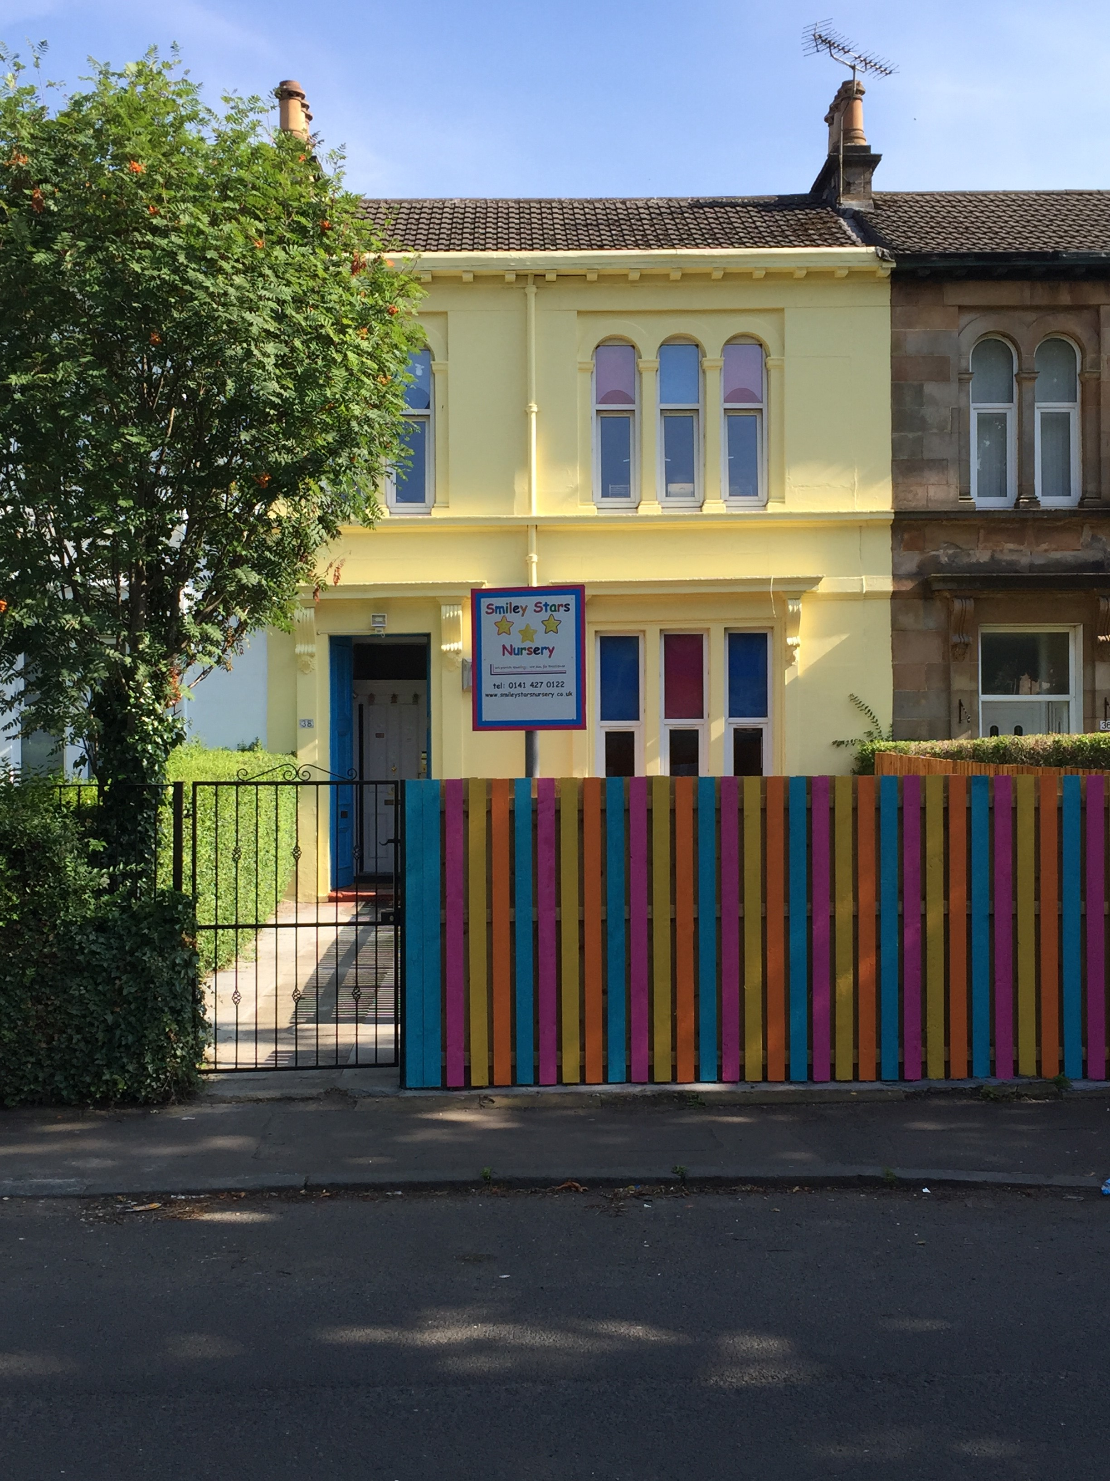

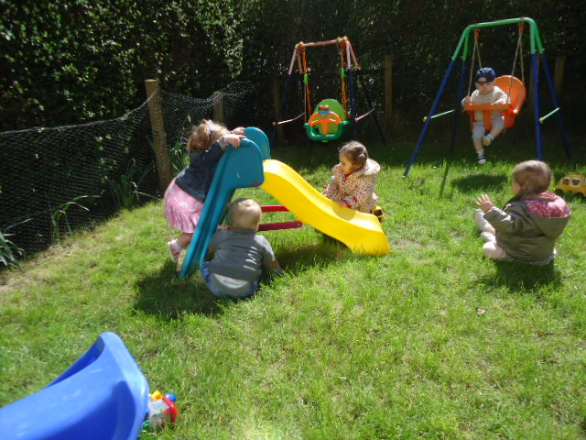
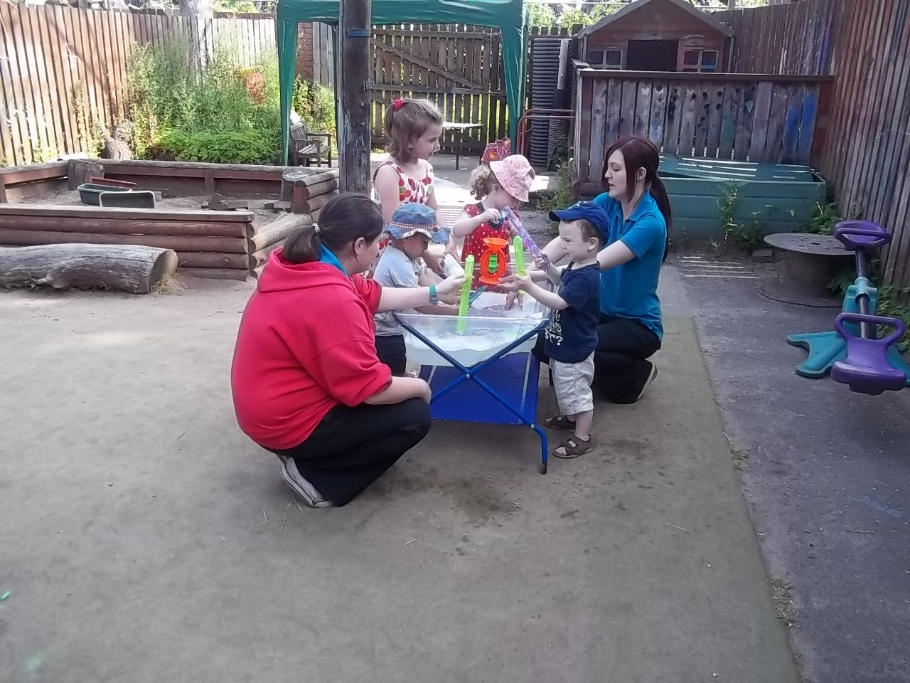

This booklet contains lots of information to help you make a big decision! We know the stresses and strains involved in choosing childcare and we’re here to help.

Smiley Stars is a small, family-run company, we are delighted to introduce you to our nursery. We think it’s something special and we’d like to share it with you.

This booklet contains:

- All-About-Us
- Our location
- Places available
- Our team
- Our opening hours
- Our fees
- Your first visit
- Our day
- Sample menu

We look forward to meeting you. Please call or email to arrange a visit or for more information – we’re always delighted to help.

All-About-Us
At Smiley Stars Nursery, we know that every child is special and that’s why our childcare service is special too. We are a family company and are delighted to introduce you to our service which is for families who want the highest standard of care for their children aged from 6 weeks to 5 years.

The first thing you’ll find with Smiley Stars is a friendly welcome. We want to get to know you because we know that a good relationship with families is the key to your child’s happiness. This helps to build trust - one of the most important things we can give you. Trust that:

- we will give your child the love and care they need and that you expect
- when your child is with us they will be truly safe and secure
- your child will have fun, eat well, enjoy fresh air and exercise balanced with sleep and rest
- Your child will be developing and learning, gaining knowledge, new skills, confidence, independence and self-esteem.

At Smiley Stars we’re really interested in children – what they need, what they like, what motivates them and how we can provide it. It takes skill to do this, especially with babies and very young children, which is why our staff team has been very carefully chosen.

We’re really interested in families too – we know the stresses of being a working parent and we’d like to help. We have an active Parent Group and can signpost you to various agencies that can help you with issues such as financing your childcare.
Smiley Stars is an active member of Glasgow South West Childcare Partnership Forum and works very closely with Glasgow City Council Education Services and we are a partnership nursery in terms of funded places for 3-5 year olds.

Our Location

We’re at 38 Ibrox Terrace, just round the corner from Ibrox Underground Station. There is lots of free on-street parking and many of our parents park here and then get the underground to work. We are very near Paisley Road West, the Clyde Tunnel, The New Queen Elizabeth University Hospital, the M8 and the M77. The Clyde Arc (Squinty!) bridge is a few minutes away, making us even more accessible to the city centre.

At Smiley Stars, we all share a love of the outdoors and we also enjoy a cosy indoors, to come home to. We have a lovely big terraced house and gardens and lots of good things to play with and enjoy.

Our front door is level with the garden which is secure for the children to play in. Downstairs is for our babies up to 2 years old. We have two lovely playrooms and a clean and comfortable changing area. The kitchen and messy playroom are also downstairs. Access to the large, secure back garden is via the back door.

Upstairs we have 2 exciting playrooms for our 2-5 year olds together with toilets, office and staff room.
Our outdoors is as much a playroom and learning experience as the indoors. We use our gardens as much as possible, believing that there’s no such thing as unsuitable weather – only unsuitable clothing.

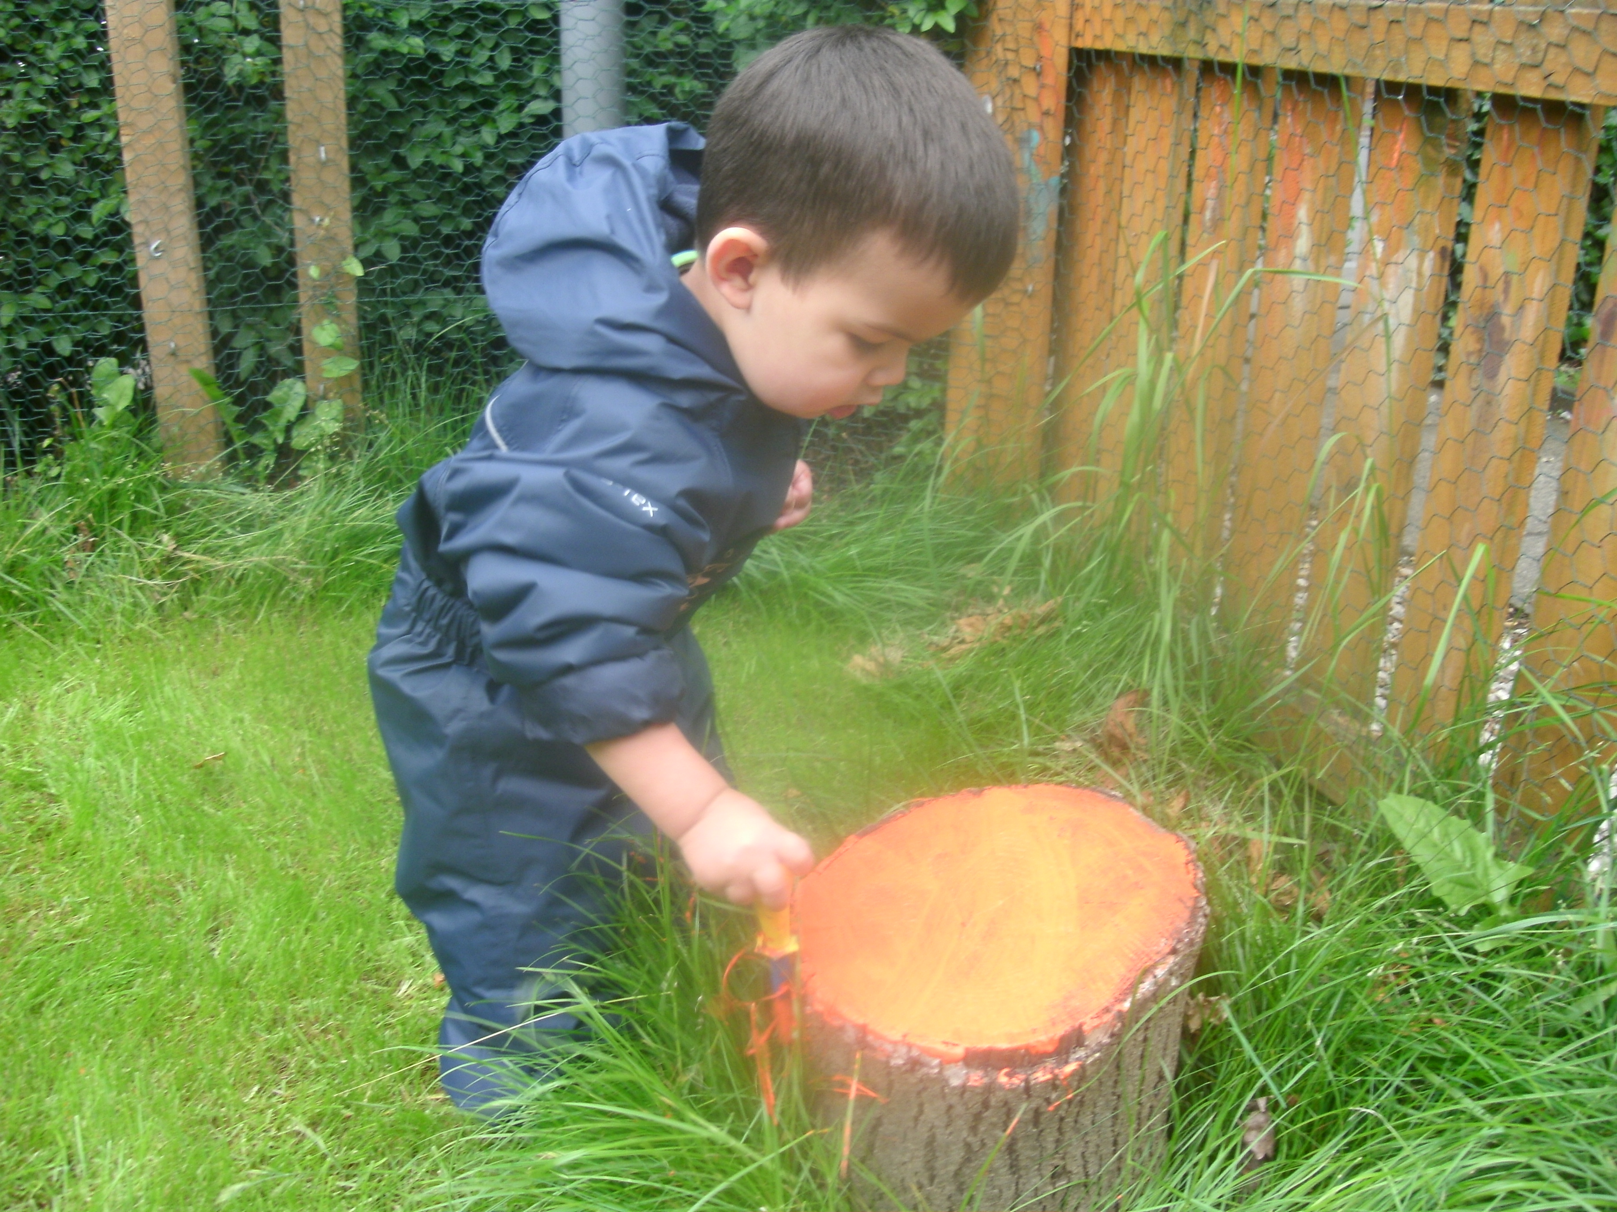

Places available
We are registered by the Care inspectorate to care for a maximum of 39 children aged from birth to 5 years.
Please ‘phone, email or see our website for details of any vacancies or to put your name on our waiting list.

Our Team
Staff are the most valuable resource that the children can have and we observe staff: child ratios required by the Care inspectorate to ensure that your child is happy and secure.
Our Manager is Tamara Marashi and Depute Manager is Jane Scott, both well qualified and very experienced practitioners.

As a small nursery, everybody knows everybody else as we work as a whole team. All of our staff are thoroughly vetted, hold the required qualifications and are registered, or in the process of registering, with the Scottish Social Services Council

Staff training is high on our agenda and we offer training in many areas including child protection, infection control, first aid and food hygiene.

Your first visit is very important and you will be made very welcome. You will be shown round our nursery and gardens and introduced to our team. You and your child are welcome to join in with any of the activities and we can chat about the kind of service you require over a cup of coffee. Families come in all shapes and sizes and you’re all welcome at Smiley Stars!

Enrolment
If you decide you would like to join us at Smiley Stars, we will ask you for deposit of £50 which will secure your child’s place. This will be refunded on your child’s last day subject to receiving one months notice and payment of all outstanding fees, however should you decide to cancel your place the deposit is non refundable. And to complete the following forms:

- enrolment form
- Terms and Conditions
- All-About-Me – this tells us all those important little things about your child like what they like to eat, what they like playing with and special words they use. This gives the staff important information and helps your child to settle in
- NHS Tooth brushing consent – Smiley Stars has ‘Smile Nursery’ status accredited by NHS Greater Glasgow and Clyde

Settling-in is such an important time and should never be rushed. We encourage you to take as long as you and your child need and will work very closely with you to make sure we’re doing everything we can to help you and your child feel happy and secure with us. Every family’s situation is different so settling-in is agreed on an individual basis to suit not only your child’s needs but your needs too.

So now that you’ve met us, enrolled and settled-in, before we can have some fun there are some extremely important issues that we have to take care of and you should be able to take totally for granted. These include……………….

Infection Control, Health & Safety and Child Protection which are so important that we want you to be secure in the knowledge that we follow strict procedures to ensure the wellbeing and protection of everyone at Smiley Stars. We are registered with the RBS Health & Safety Mentor service and our staff team includes a Fire Safety Officer and Health and Safety Officer.

Confidentiality which is strictly observed. Client information is securely stored and used solely for Smiley Stars Nursery purposes. The only exception to this is in the event of serious concerns regarding a child’s welfare. This is explained in our Child Protection policy.

Our policies are included in our Parent Information Book which is kept beside our Information Board and is available to all parents.

Opening Hours
We are open from 8.00am to 6.00pm Monday to Friday, 51 weeks of the year. Last pick up time is 5:50 please allow 10 minutes for feedback so staff can leave promptly at 6 pm.

By Arrangement we now offer earlier dropping times at 7am and later picking up time 6.20pm

Our Day
This will vary depending on the stage your child is at. Every child has a Key Worker who is their main carer in the nursery and is responsible for meeting their needs. For registration purposes, the children are based in separate areas of the nursery according to their age. At Smiley Stars however, we firmly believe that the different age groups should have opportunities to come together, e.g. in the garden, at mealtimes and at night when sessions are quieter. This not only benefits their development but also eases transition from one area of the nursery to another.

Mealtimes should be one of life’s pleasures and at Smiley Stars we aim for everyone to enjoy not only the food but also the experience. The children will be given opportunities to set the table, decorate it for special occasions and help to prepare the food. Our cook provides a range of homemade delicious, nutritious meals and snacks, which as far as possible is free from artificial additives and low in sugar and salt. A sample menu is attached. Mealtimes are a great opportunity for socialising and staff will encourage this enjoyable activity by sitting at the table with the children.

Breakfast, lunch and snacks are all included in your fees depending on your session times. Breakfast will be offered to children attending the nursery before 9.00am.

For babies who are weaning we will work with you to ensure your child has the most appropriate diet.
We are a Breastfeeding Welcome accredited nursery and fully support mothers who wish to continue to breastfeed their babies.

If your child has any special dietary requirements and/or have allergies we will work closely with you to ensure your child’s needs are met.

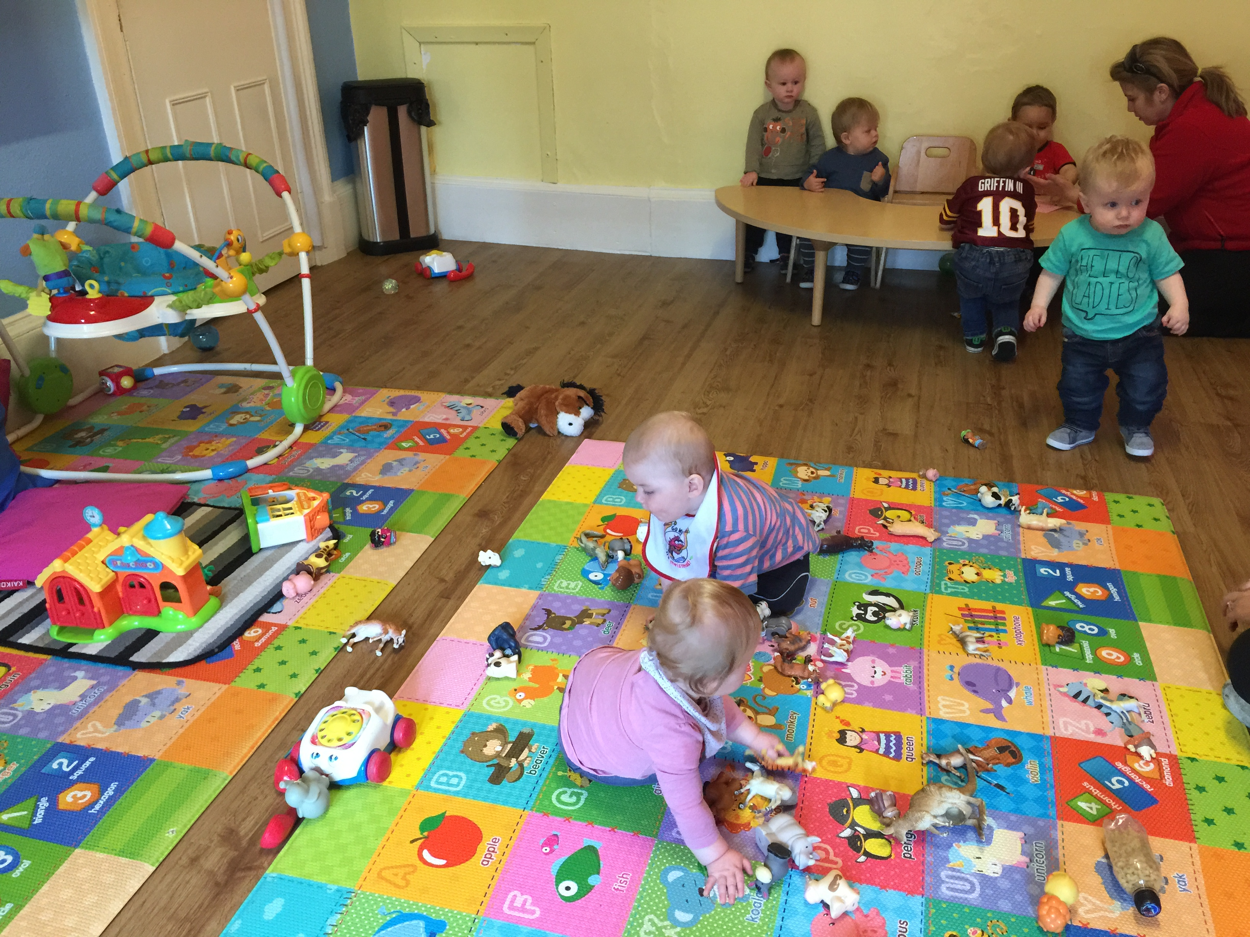
Babies.... Spend a lot of their day feeding, changing and sleeping (As you know only too well!). Baby Room staff and care routines provide great opportunities for babies. They thrive on - cuddles, songs, rhymes, peek-a-boo, tickles and fun and we will meet their individual needs Familiar experiences are very important but so are new ones. We have…………………………..
- comfy cushions for snuggling and stories
- textured rugs and colourful mats for lying, kicking, crawling and playing on
- sturdy, low furniture to pull up to standing on
- family photos and familiar household objects
- treasure baskets and discovery bags for exploring
- puppets, music, blocks, paint and water……………………………we love our baby room!

As babies move into their second year visits to the 2-3 Room to enhance their transition, there are lots of further exciting opportunities for play while maintaining that important familiarity.
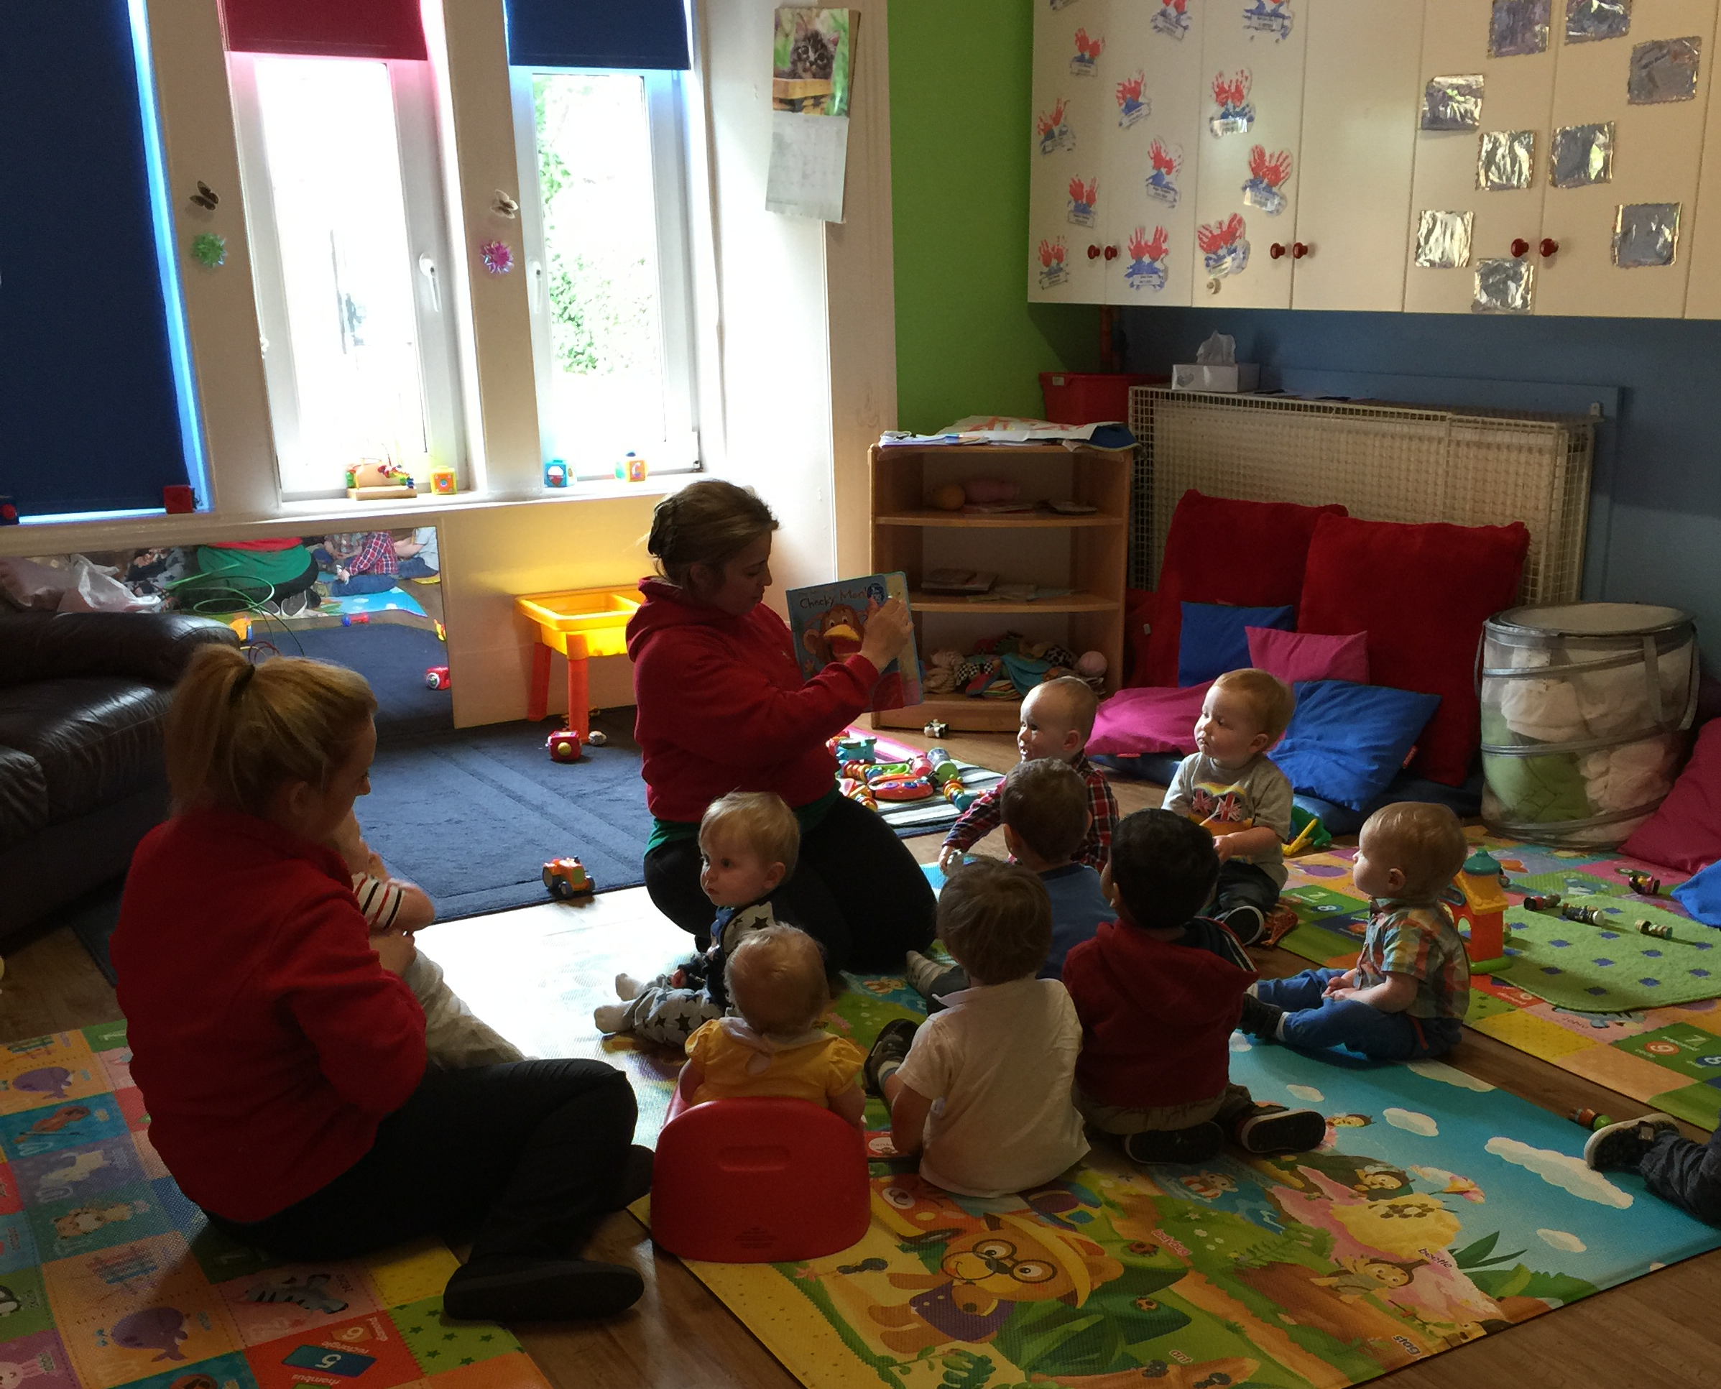
Your baby’s Key Worker will ensure that a variety of activities and experiences is offered to complement their care routine – sand, water, drawing, playdough, jigsaws, jumping, climbing, sliding, pushing and pulling to name but a few.

2 year olds………
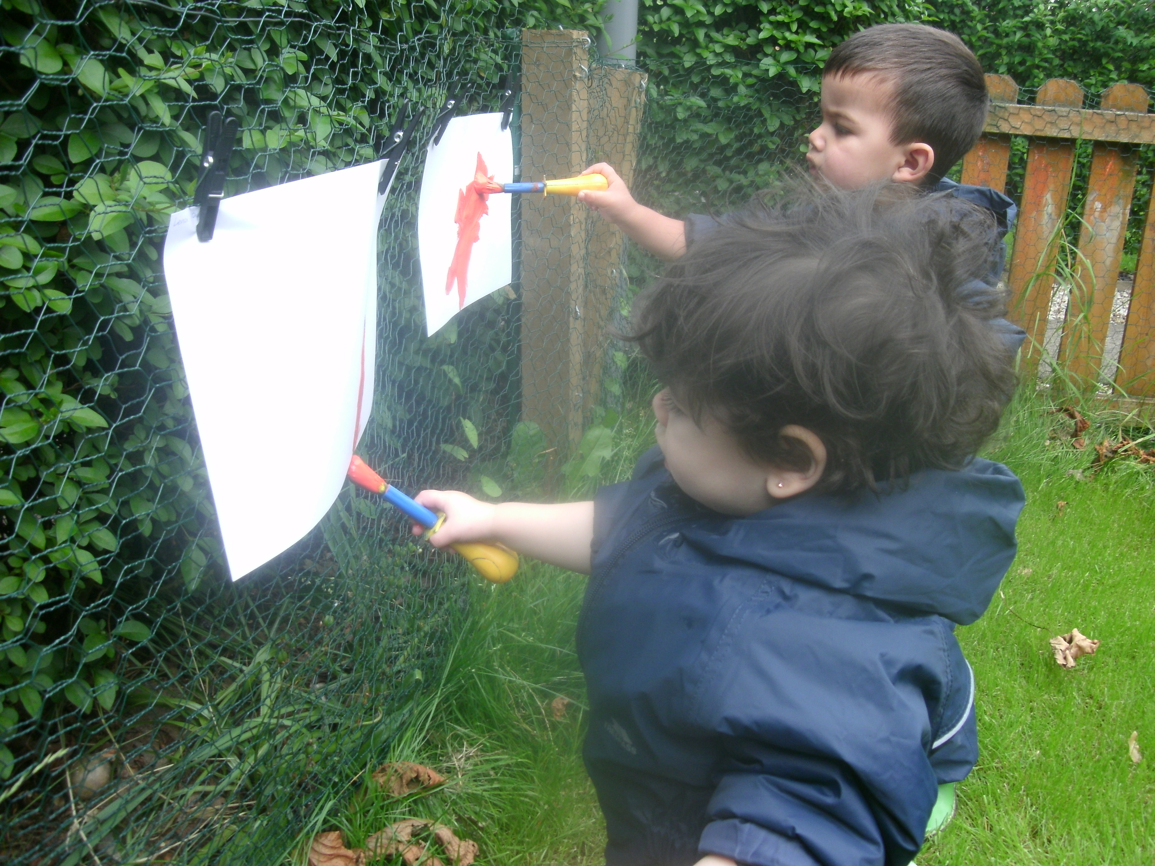
Here they are offered experiences they enjoyed in the baby room together with lots more opportunities to make the most of this rapid stage of development.


Outdoor play is a good example – familiar territory but now we can try more climbing, riding, running, playing ball, digging and planting.

3 and 4 year olds ……….Still need love and cuddles but their Key Worker will also plan activities and experiences (in line with the Scottish Government’s ‘Curriculum for Excellence’) that meet the children’s ever-expanding needs. This will involve familiar experiences developing into more challenging activities balanced with time just ‘to be’………particularly appropriate for full day children or those who have been to another setting for part of the day. We have so much fun with opportunities for:

- drawing, early writing, books and stories

- science, early number, baking and discovery
- building and small world play
- painting and crafts
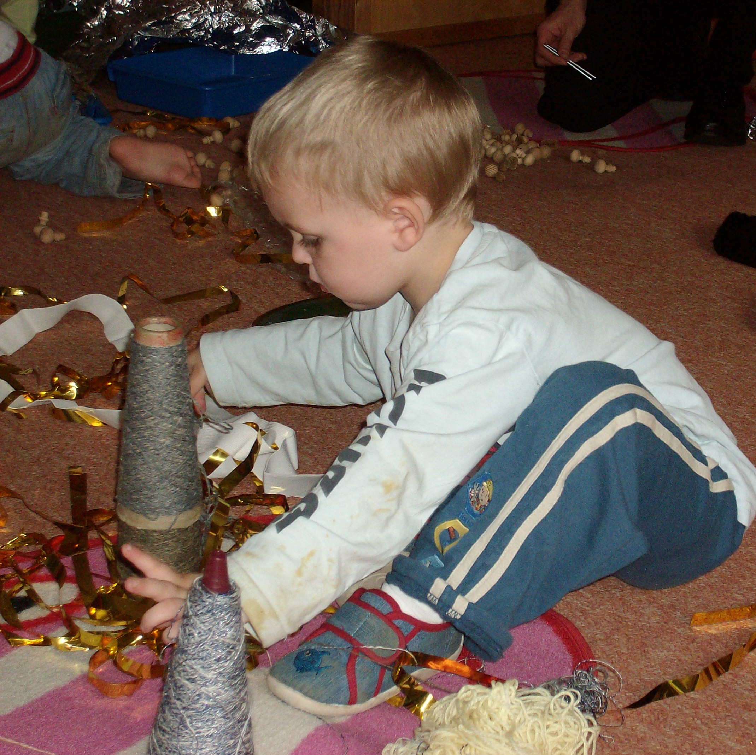
- ‘let’s pretend’
- music and movement

and as often as possible we’re outside
- getting messy and having fun
- running, jumping, skipping and hopping
- climbing, riding, bouncing and sliding
- digging, planting, collecting and sorting
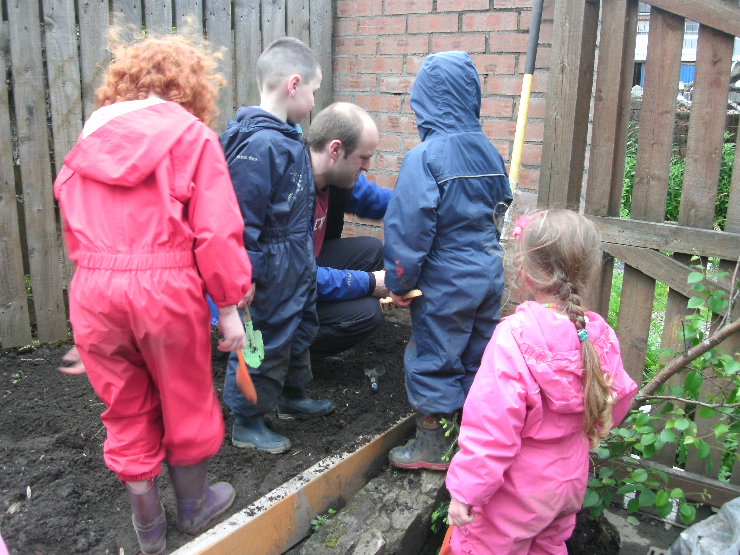
- drawing, painting, taking photos

and we don’t forget that sometimes we just need a little rest and to relax……..so when we get towards the end of our day we like to slow things down a bit and get ready for ‘going-home time’ which we will manage to suit your needs. Some parents like to come in for a chat, others want to get home ASAP – whatever you need, we’ll do our best to help.
What did some of our parents have said about us?

“Thank you, you are the best because you brought out the BEST in me” KN parent of ON

"I am delighted with the care my children receive at Smiley Stars Nursery. Tamara has provided great leadership and direction. Tamara started to make improvements as soon as she took over the business. Viewing windows, new flooring, new blinds and a lick of paint name just a few.

Tamara is genuinely interested in creating the best possible environment for the children in her care and Smiley Stars is like a home away from home for my children. This gives me great peace of mind." K M Parent of J and F

“My daughter has flourished at Smiley Stars Nursery; she is happy, has grown in confidence, and I am delighted with the care that my daughter receives. Thank you so very much” TR

Our Fees
All fees are payable in advance and due in the 1^{st week} of the month. Payment by standing order is preferable. We accept all Childcare Vouchers.

Full fees must be paid during holidays and absences.
Weekly – Breakfast, snacks and lunch included
Monday – Friday 8.00am – 5:50 pm
Daily – Breakfast, snacks and lunch included 8.00am – 5:50 pm
Morning - Breakfast and lunch included 8.00am – 1.00pm
Afternoon - Snack included 1.00pm – 5:50 pm
Dinner |  |  |  | £1
Any Additional hour - Between 8.00am and 6.00pm |  |  |  | £6
SESSION | Baby Room | 2-3 Room | 3-5 Room
Weekly | £175 | £175 | £160
Daily | £40 | £40 | £39
Morning | £24 | £24 | £23
Afternoon | £23 | £23 | £22
Additional hours - (7.00am-8.00am) & (6.00pm-6.20pm)
 | 0-30 mins | 30-45 mins | 45-60 mins
Before 8am | £3 | £4.50 | £6
After 6pm | £3 | - | -
NB. Reduced fees i.e. after a birthday will be applicable the month following each child’s birthday.

A 10% discount based on the oldest child’s fees is given to families with 2 or more children. When a place has been confirmed a £50 deposit is required to secure your child’s place. This will be refunded on your child’s last day subject to receiving one months notice and payment of all outstanding fees, however should you decide to cancel your place the deposit is non refundable.

Please note that Smiley Stars reserves the right to withdraw any offers given at the time of registration and to increase our prices in line with inflation.

As we said before, families come in all shapes and sizes and at Smiley Stars everyone is welcome. We understand that parents can have different working patterns and therefore need childcare that can be adapted to suit their needs. We offer a wide range of options for families who have different work patterns or work shifts.

Please contact the nursery for more information.

Please let us know right away if you anticipate any difficulty with payment. We may be able to help.

Phone us now or email us for a chat - we’d love to hear from you and discuss how we can help with your childcare needs.

Smiley Stars Nursery - Sample Menu
All cooked meals are vegetarian and homemade
Yummy, yummy, yummy, delicious and nutritious, our wholesome and nourishing menus are specially designed to give your little one the very best start in life.
We believe that meal-times should be a happy, relaxed time where children learn social skills, manners, good hygiene practice and healthy eating habits to last them a lifetime.
 | Monday | Tuesday | Wednesday | Thursday | Friday
Breakfast | Selection of Fruit, Selection of cereals. Toast
Lunch | Tomato Mushroom Pasta  Garlic Bread | Veg. Mince & potatoes  Fromage Frais | Fish fingers, croquette & Beans  Fruit Salad | Lasagne  Fromage Frais | Sausage Hotpot  Frozen Mousse
P.M. Snack | Selection of Fruit
P.M. Snack | crackers | Brioche | Fruit loaf | Waffles | Malt Loaf

All meals are served with milk or water
At least 2 types of fruit are served with breakfast and snack

Terms and conditions of enrolment and parental consents
Please read carefully the following terms, conditions and parental consent requirements, and then please sign where requested.

General Welfare

- Child protection: Smiley Stars management and staff have a duty to take reasonable care to ensure the welfare and safety of the children in our care. Any serious concerns regarding a child’s welfare or safety will be dealt with in accordance with Smiley Stars Child Protection Policy and Procedures. Parents/guardians should be aware that this may require us to contact Social Services.

- Child safety: Children will only be released to parents/guardians or authorised persons, i.e. carers or family members who are known to the nursery staff and permission in writing has been received from the parents/guardians. In unforeseen circumstances where an unauthorised person has to collect the child, the parents/guardians must inform the nursery and provide a password, and we require a proof of photographic ID.

- Confidentiality: All information relating to you and your child is strictly confidential, securely stored and used solely for Smiley Stars Nursery purposes. The only exception to this is in the event of serious concerns regarding a child’s welfare. You are welcome to access your child’s records at any time.

- Child observations: We regularly observe all of the children in our care to ensure that we meet their needs effectively. Observations are recorded in writing, are strictly confidential and are filed in the child’s confidential folder.

- Outings: We will sometimes take the children on outings within the immediate area on foot/using prams and buggies as appropriate. Risk assessments are always carried out in advance and ratios will always be adhered to. I give permission for my child to go on outings within the immediate area. I will ensure that my child is provided with suitable clothing for my child to take part in outdoor activities.

- Tooth-brushing Consent Form: I wish my child to take part in Smiley Stars Tooth-Brushing Policy and we will provide my child with a clearly labeled toothbrush and toothpaste.

- Access to the Internet for 2-5 Children: Access to the Internet will be under strict supervision from room staff, I give my consent for my child to use the Internet within the Nursery.

- Start and finish times: Children can be cared for within the nursery hours stated on our Registration Certificate on display in the hall. Late collection will invoke an additional charge of £5.00 for every 10 minutes (full or part of) thereafter.

Medical, Health & Wellbeing

- Accidents or emergencies: Every endeavour will be made to contact you in the event of an accident or emergency or the sudden onset of illness but we will not delay in seeking medical help. I will be fully informed of any decisions made. I give permission for Smiley Stars Nursery to take appropriate action in the event of the onset of illness, accident or emergency.

- Medical conditions, allergies and illness: Parents/guardians and carers must keep us informed of any allergies, medical conditions and illness affecting their child. Parents/guardians and carers must NOT bring their child to nursery if they are ill or have an infectious disease. This is for the health and welfare of ALL children and staff in the nursery. You will be contacted to take your child home if staff considers that your child is not well enough to attend nursery.

- I agree to inform the nursery immediately if my child has, or develops, an allergy, illness or medical condition and to provide the nursery with the information required regarding the allergy or condition to ensure my child’s wellbeing.

- Smiley Stars staff should not be put in the difficult position of turning a child away at the door because they are obviously not well. The problems this causes for the child, the nursery and the other children cannot be over-emphasised. Children play closely together which means that an un-well child can infect many other children and staff who in turn can infect yet more people. Some children may have only just recovered from one infection when they are exposed to another. Please follow the guidance below to help to promote the health and welfare of everyone involved. Children will not be admitted with infectious diseases (e.g. chicken pox) in accordance with the exclusion periods stated at NHS Exclusion Criteria for Childcare and Childminding Settings

- If we suspect that a child has a raised temperature, we will check it using a thermometer. If the temperature is above 37.5°C the parent will be contacted.

- If a child appears to be clearly unwell, e.g. hot, restless, sick, the parent will be contacted and asked to take the child home, unless the parent has signed a Medication Form on the day.

- Medication: Nursery staff can administer medication required by your child providing that the medication is named for your child and that you have completed a medication consent form, which gives detailed instructions on dosage. Details of medication administered by nursery staff will be recorded and must be signed by you on a daily basis. You must always give the first dose of any medication, and allow time before your child attends the nursery.

- Medication prescribed and non prescribed is only given if it is in its original container and supplied with the pharmacy label ON THE BOTTLE – parents should ensure they request this when buying the medication from the pharmacy. It cannot be given if the label is on the box. The label must clearly state the child’s name, dosage and have a valid date.

- Application of sunscreen &/or nappy cream: I agree that Smiley Stars staff may apply sunscreen/nappy cream to my child’s skin if and when required. I am not aware of any allergy to sunscreen/nappy cream products.

Photographs & Media

I give permission for the Photos & Media taken for my child to be displayed within the nursery and in my child's records and I give permission for the photos to be used for:
- Publicity (e.g. Newspaper articles, Nursery’s website, Facebook & Welcome pack)
- Staff training
- Student portfolios

Communication
- I will provide Smiley Stars with details of ANY issues, which may affect the care, which they provide for my child, as soon as possible

- I will inform Smiley Stars of ANY issues which may result in a change in my child’s behaviour and/or if I have experienced a change or difference in my child’s behavior

- I will inform Smiley Stars of ANY changes to my contact details or any other information given on my child’s enrolment form, as soon as possible and will adhere to the Smiley Stars Terms & Conditions

- I will notify the nursery, either by phone call or by Email that my child will not be attending their session

Financial

- Fees are payable one month in advance and due on the 1st of each month and no further than 10th of each month. Payment may be made cash or by standing order, we accept childcare vouchers. Late payments will incur an additional charge of £25 per week until full payment is made.

- Extra sessions must be paid for in advance.

- Please note that Smiley Stars reserves the right to withdraw any offers given at the time of registration
- When we confirm your child’s place, a £50 deposit is required which will be refunded when and if you give us 1 month notice prior to you and your child no longer wish to use our services and all fees being up to date from your final invoice. Should you decide to cancel your place, the deposit is non-refundable.

- In order to retain your child’s place, full fees are paid during holidays and absences to retain your child’s place.

- All fees will be increased on an annual base on the first of March each year

Notice
- I will provide one month’s notice in writing or payment of one month’s fees in lieu of notice must be given if I wish to withdraw my child from the nursery, and receive my deposit back.

- I will provide one month’s notice, in writing, if there is any change to my childcare requirement at the Smiley Stars Nursery (reduce days)

- Smiley Stars Nursery reserves the right to require the withdrawal of any child.

Behaviour Management and Promoting Positive Behaviour Contract

- I will be supportive of the Smiley Stars staff when implementing the Behavioural Management Policy and the three way contract between Smiley Stars , Parents & my Children

- I understand that if my child’s behaviour is such that the health and safety of other children and/or staff is put in jeopardy, they may be excluded from the nursery on a temporary or permanent basis

- I understand that Smiley Stars has a zero tolerance towards violent or aggressive behaviour towards their staff. If a child or parent displays such behaviour, I understand that this may result in my child being excluded from the nursery and their space withdrawn immediately

- We have read Smiley Stars Nursery Behaviour Management Policy, understand what is required from us and we agree to support this initiative

Appendix 1a: Illness & communicable diseases exclusion procedures - NHS Guidelines
Disease/Illness | Minimal exclusion period
Vomiting (Viral) | 48 hours from last episode of illness.
Diarrhoea | 48 hours after last episode of Diarrhoea.
Conjunctivitis (Bacterial) | Until treatment has started.
Infection of the throat | Until appropriate medical treatment has been given and
Impetigo | Until sores are crusted or healed or until 48 hours after antibiotic treatment has started
Pediculosis (head lice) | Until appropriate treatment has been given
Ringworm of scalp | No exclusion. Should be treated and covered, until cured
Ringworm of Body | Seldom necessary to exclude provided treatment is being given
Scabies | Need not be excluded once appropriate treatment has been given
Hand, foot and mouth | 1 week off from onset of rash
Chickenpox | 5 days from onset of rash
Gastro-enteritis, & dysentery | Until authorised by District Community Physician
Food poisoning, Salmonellas | Until authorised by District Community Physician
Infective Hepatitis | 7 days from onset of jaundice
Measles | 4 days from onset of rash
Meningococcal infection | Until recovered from the illness
Mumps | 5 days from onset of swollen glands
Pertussis (whooping cough) | 5 days from commencing antibiotic treatment or 21 days from onset of illness if no antibiotic treatment
Poliomyelitis | Until declared free from infection by District Community Physician
Rubella (German measles) | 6 days from onset of rash
Scarlet Fever & Streptococcal | 24 hours after commencing antibiotics
Tuberculosis* | Until declared free from infection by The District Community Physician
Typhoid Fever | Until declared free from inspection by the District Community Physician
* Please note that most childhood Tuberculosis is not contagious.

